**Step 1.** Get all the parts you will need:

1. Arduino UNO board
2. HX711 sensor amplifier
3. USB A/B 2.0 cord
4. Load Cell
5. 4 small wires to connect Arduino to HX711
   1. One red
   2. One black
   3. One blue
   4. One green

**Step 2:** Connecting everything: in the diagram the green wire connecting the Arduino to the HX711. (Red wire needs to be connected to the 5v pin instead of the 3.3v pin on the Arduino UNO board)

**Step 3:** Plug in the USB cord to the Arduino and your laptop.

**Step 4:** Open the Arduino IDE Software website and install the Software: <https://www.arduino.cc/en/software>

**Step 5:** Go to the link below and copy the code for the Arduino to run the scale:

<https://github.com/Swimmerboyk/ScaleCode/blob/main/Arduino%20Scale%20Code>

**Step 6:** Then Paste the code into the IDE.

**Step 7:** Import and install the Queuetue HX711 Library:

**Step 8:** Go to the top left part of the window then select the verify button, it looks like a check mark (shown below):

**

**

**Step 11:** Use a 15 lbs weight to Calabrate the scale(users scale may look different): 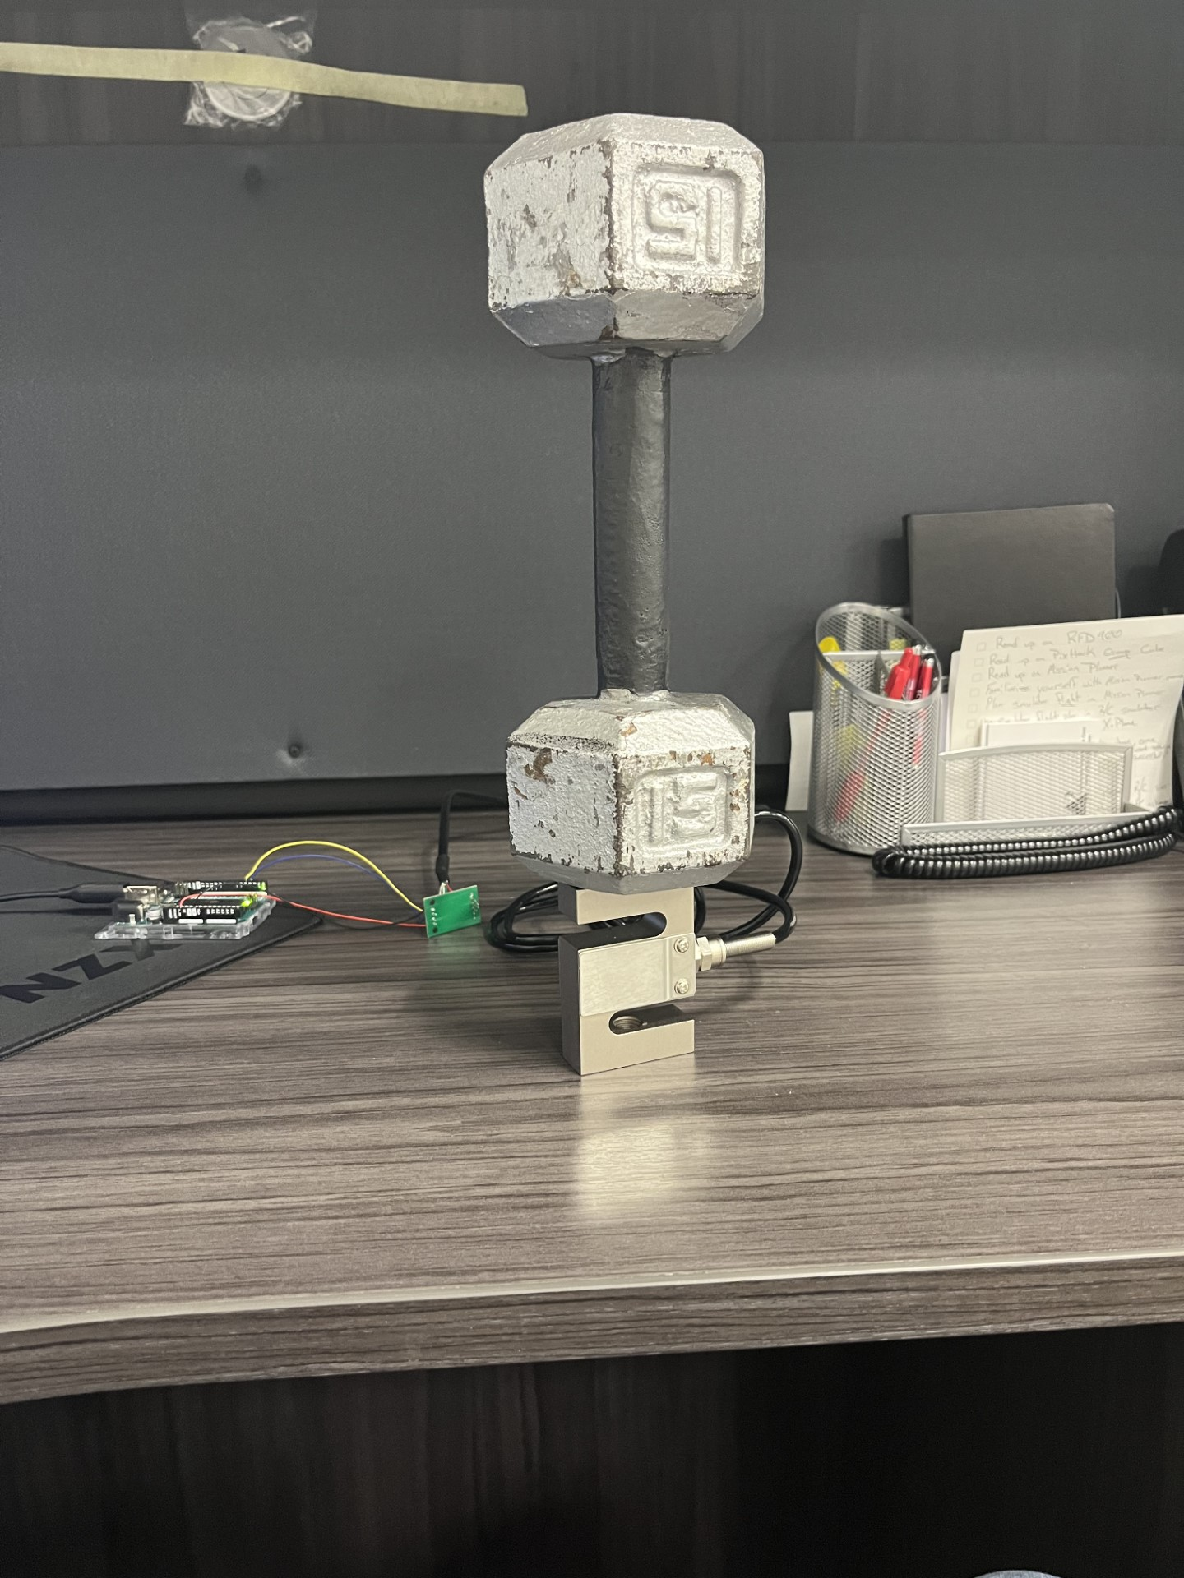

**Step 12:** Place Rocket on scale/ test stand:

**Step 13:** whenever you want the scale to start take readings just enter any button on the computer into the srial monitor command line( shown below)

**Step 14:** After pressing enter the program will run till there are 200 outputs and after the 200th output it will print “END”.

**Step 15:** Then copy all the outputsfrom the serial monitor to an excel sheet for later use.

**NOTE:** To have the Time displayed on the serial monitor press the little clock icon on the top right corner of the serial Monitor.

**NOTE:** Restart the program by just pressing the upload button again.

**NOTE:** If you want to erase all the previous outputs you will need to press the clear output button that is right next to the clock button shown above.